National Park Service  U.S. Department of the Interior | Zion National Park  Use the complete site name here (e.g. Palo Alto Battlefield Historic Site). |  | Springdale, Utah 84767  435 772-3256 phone  435 772-3426 fax  www.nps.gov/zion
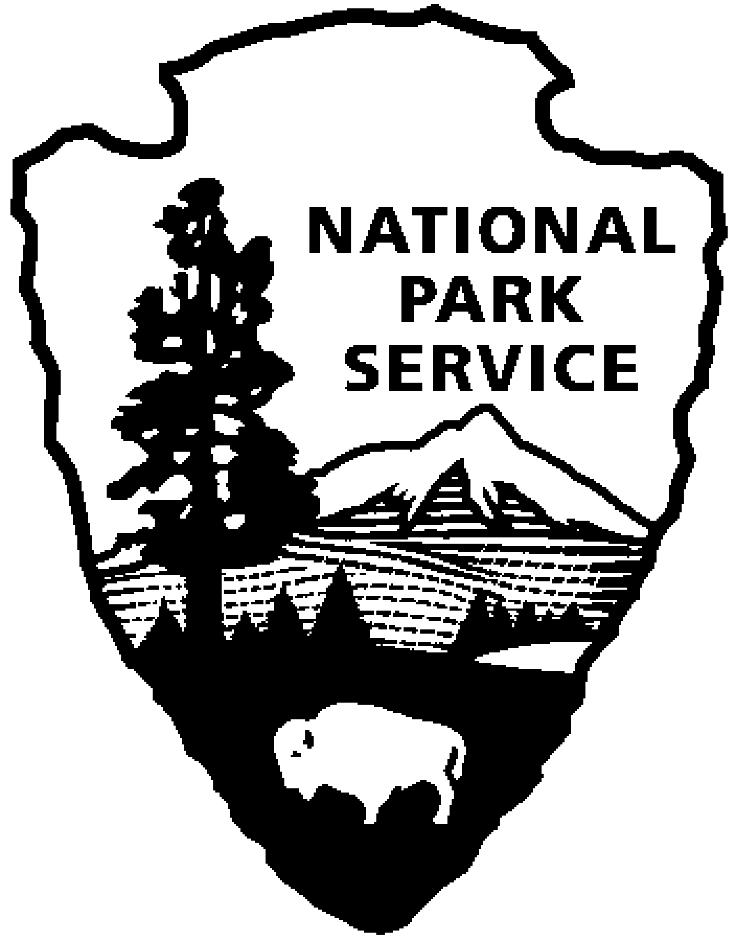
Zion National Park News Release
Use a “short-hand” version of the site name here (e.g. Palo Alto Battlefield not Palo Alto Battlefield National Historical Site).

October 11, 2007
For Immediate Release
Ron Terry 435 772-0160
David Eaker 435 772-7811
07-33

Zion National Park to Begin Post-Fire Rehabilitation

Zion National Park Superintendent Jock Whitworth announces the completion of the Post-Fire Aerial Application of Herbicide Environmental Assessment (EA) and the signing of the Finding of No Significant Impact (FONSI) by the National Park Service Intermountain Regional Director.

The park will begin the aerial application of herbicide on the area burned in the Dakota Hill Complex Fire after October 21, 2007. The project is expected to last up to 3 weeks – depending on weather. The aerial application of herbicide on up to 3,161 acres within the park is intended to interrupt the grass-fire cycle that is perpetuated by cheatgrass, a non-native, highly flammable grass. Because of the remote and rough terrain in the burn area, helicopter application of the herbicide will be used. If conditions allow (weather and plant growth) portions of the area burned in the 2006 Kolob fire will also be sprayed during this time.

Be aware that during the project portions of the backcountry will be closed to visitor use. Closures will affect routes and trails accessed from the West Rim Trail. Check at the visitor center or the park website www.nps.gov/zion for the most current information.

For more information on this project please contact Kelly Fuhrmann, Zion Fire Ecologist, at (435) 772-0193 or kelly_fuhrmann@nps.gov. To obtain a copy of the FONSI, visit the park website at www.nps.gov/zion.

-NPS-

